1. **Jatin:**
2. **Web Site: A set of html, JS, CSS files.**
3. **Web App**: Web site where we can enter data and that is processed on the server.
4. **Enterprise App**: Big Web App. Like Banking App.

1. Spring Framework which is Java Framework used for Web Apps and Enterprise Apps.  
   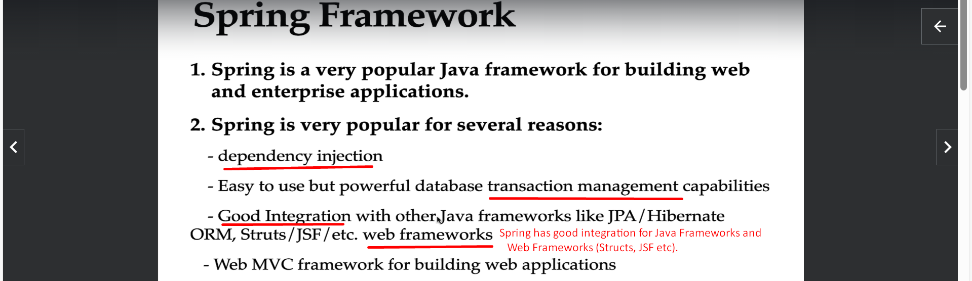
2. Spring Framework has a lot of Subprojects which help to build applications as per business models/needs.  
   